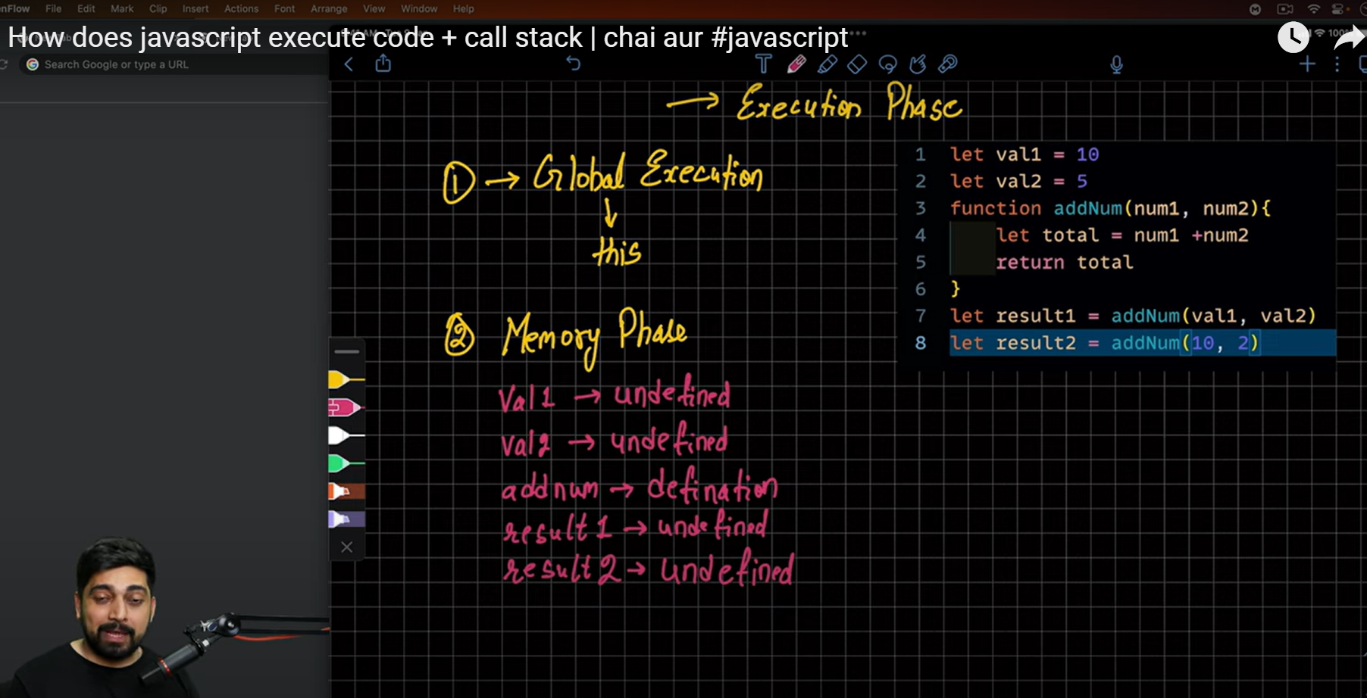

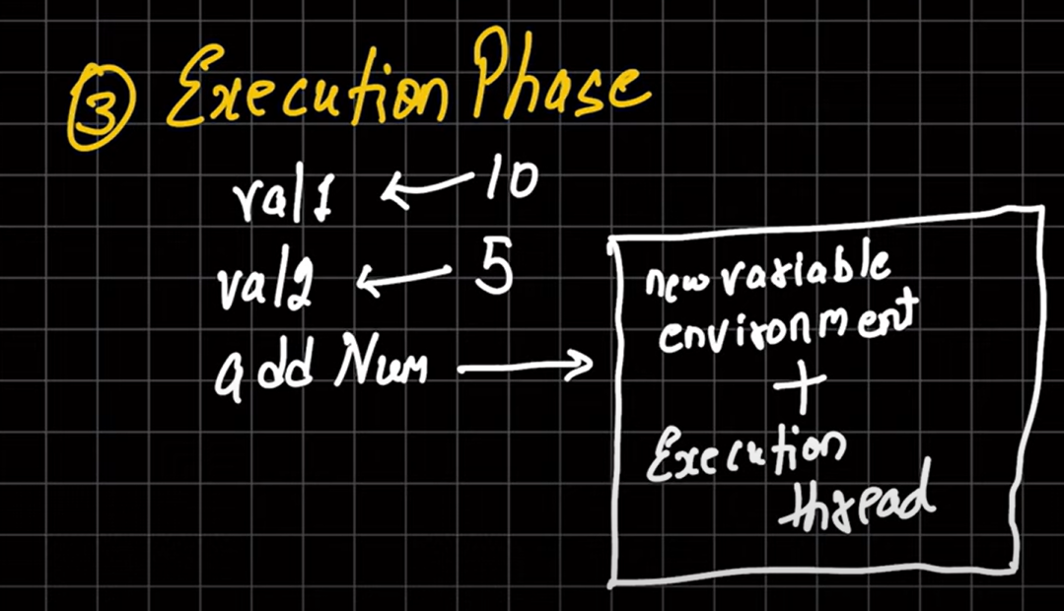

Jitni bar fxn execute hoga new envrnnmt Banega which is called new executional context.jitni bar fxn call hoga memory and execution phase fir call hoga ..

The global ec gets delted once its work is done